**Jenkins:**

What is Jenkins:

Jenkins is a continuous integration tool.

What is continuous integration?

Normal Development Process:

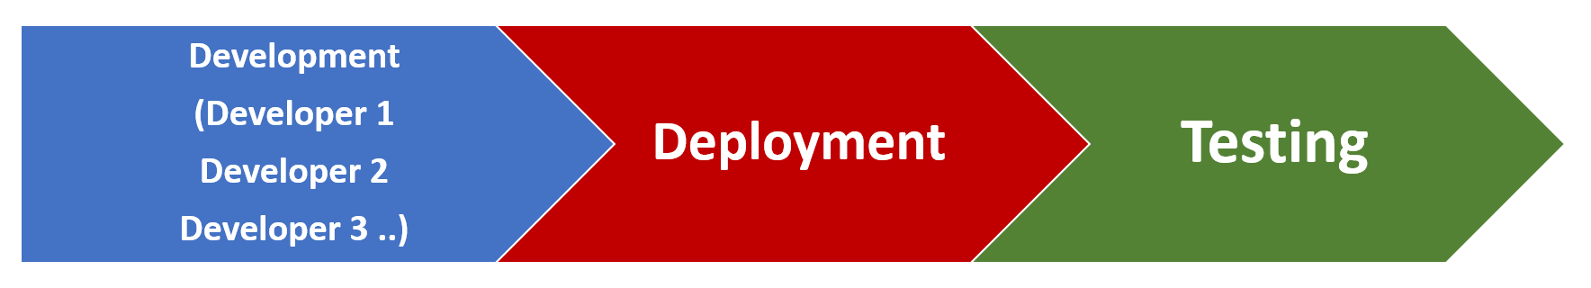

In Normal development process developers develop the code in local machine and after some time or the development is completed it will be deployed to the test environment. Once it is deployed testing will be started but because a large piece of code is deployed at one time there will be potential defects that might arise might stop the entire testing. Because one functioanality that was developed by developer 1 will be modified by the second developer at a later stage and this might result in potential defects.

In continuous integration the code that is developed by developers will be deployed to the servers many times a day and testing will be performed each time the code is deployed.

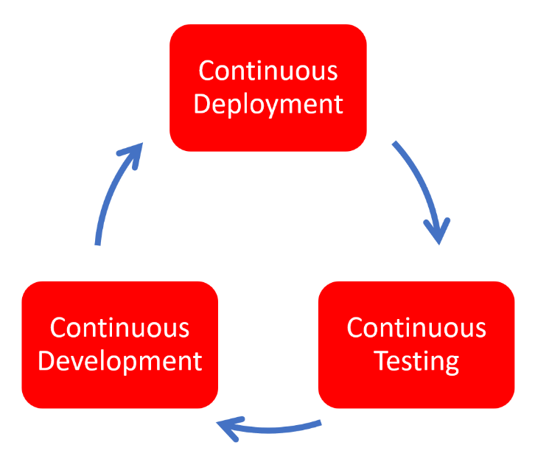

So, Continuous integration is a development practice that requires developers to integrate code into a shared repository several times a day. It is a process of running your tests on a non-developer machine automatically when someone pushes the new code into the source repository.

Using Jenkins, we can trigger tests when someone pushes new code into the repository.

Why do we need continuous integration?

Using continuous integration, we can detect problems as early as possible in the development lifecycle.

Since code is deployed, built and tested thoroughly potential defects can be caught in the early stages of life cycle.